Comments 9
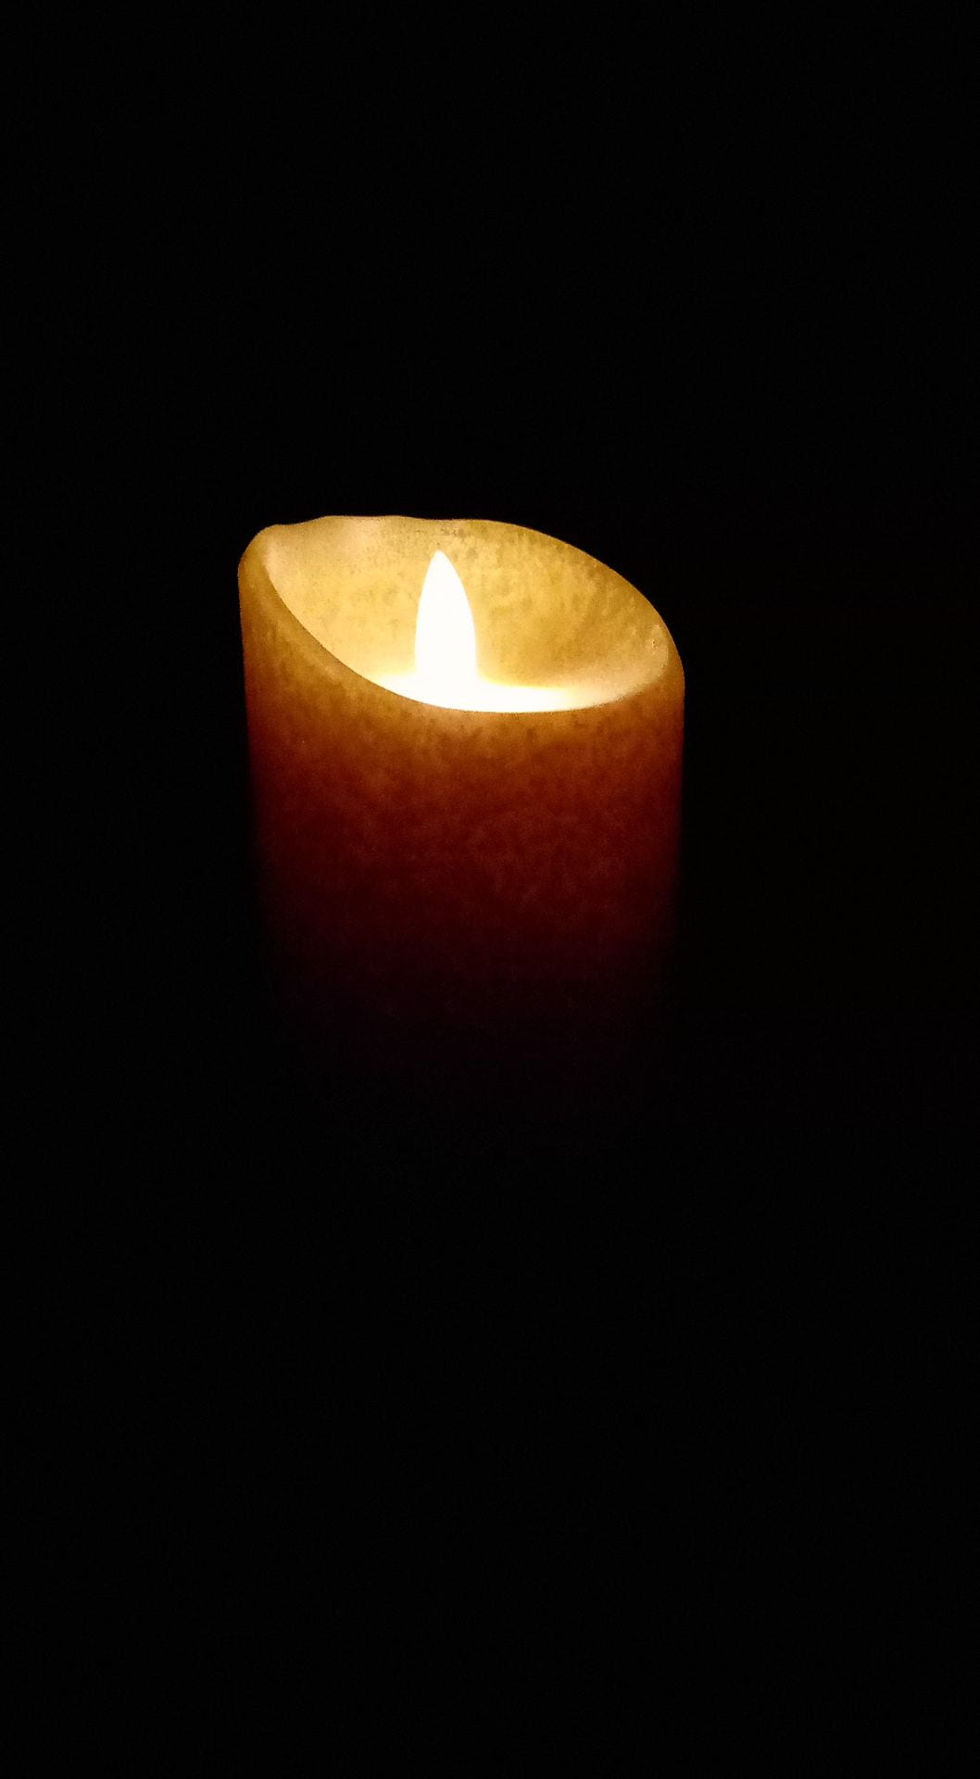Photo by Emily Whitley
This photo is so cool! I love how the candle is just floating in a dark abyss and fading away slowly. The bright white flame contrasts with the deep dark background really well, and makes you wonder what could possibly be lurking beyond.

Photo by Colton Hendricksen
I really like this photo. The arrows pointing down the line totally direct my eyes to what's beyond. I love the perspective you used with that angle. I also really like the bright colors. The title is pretty creative and fits with it well too.

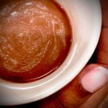Photo by Hayley Bowler
It won't let me comment on the specific photo, but I love the "Hot Chocolate" photo. I really like the white swirled into the creamy looking chocolate to add some detail. I also think your hand on the outside of the mug adds a lot to it too. The placing of the mug in the photo is also very unique and creative. This picture makes me think of curling up on the couch with a blanket on a cold winter's day in the best way possible. I love it.

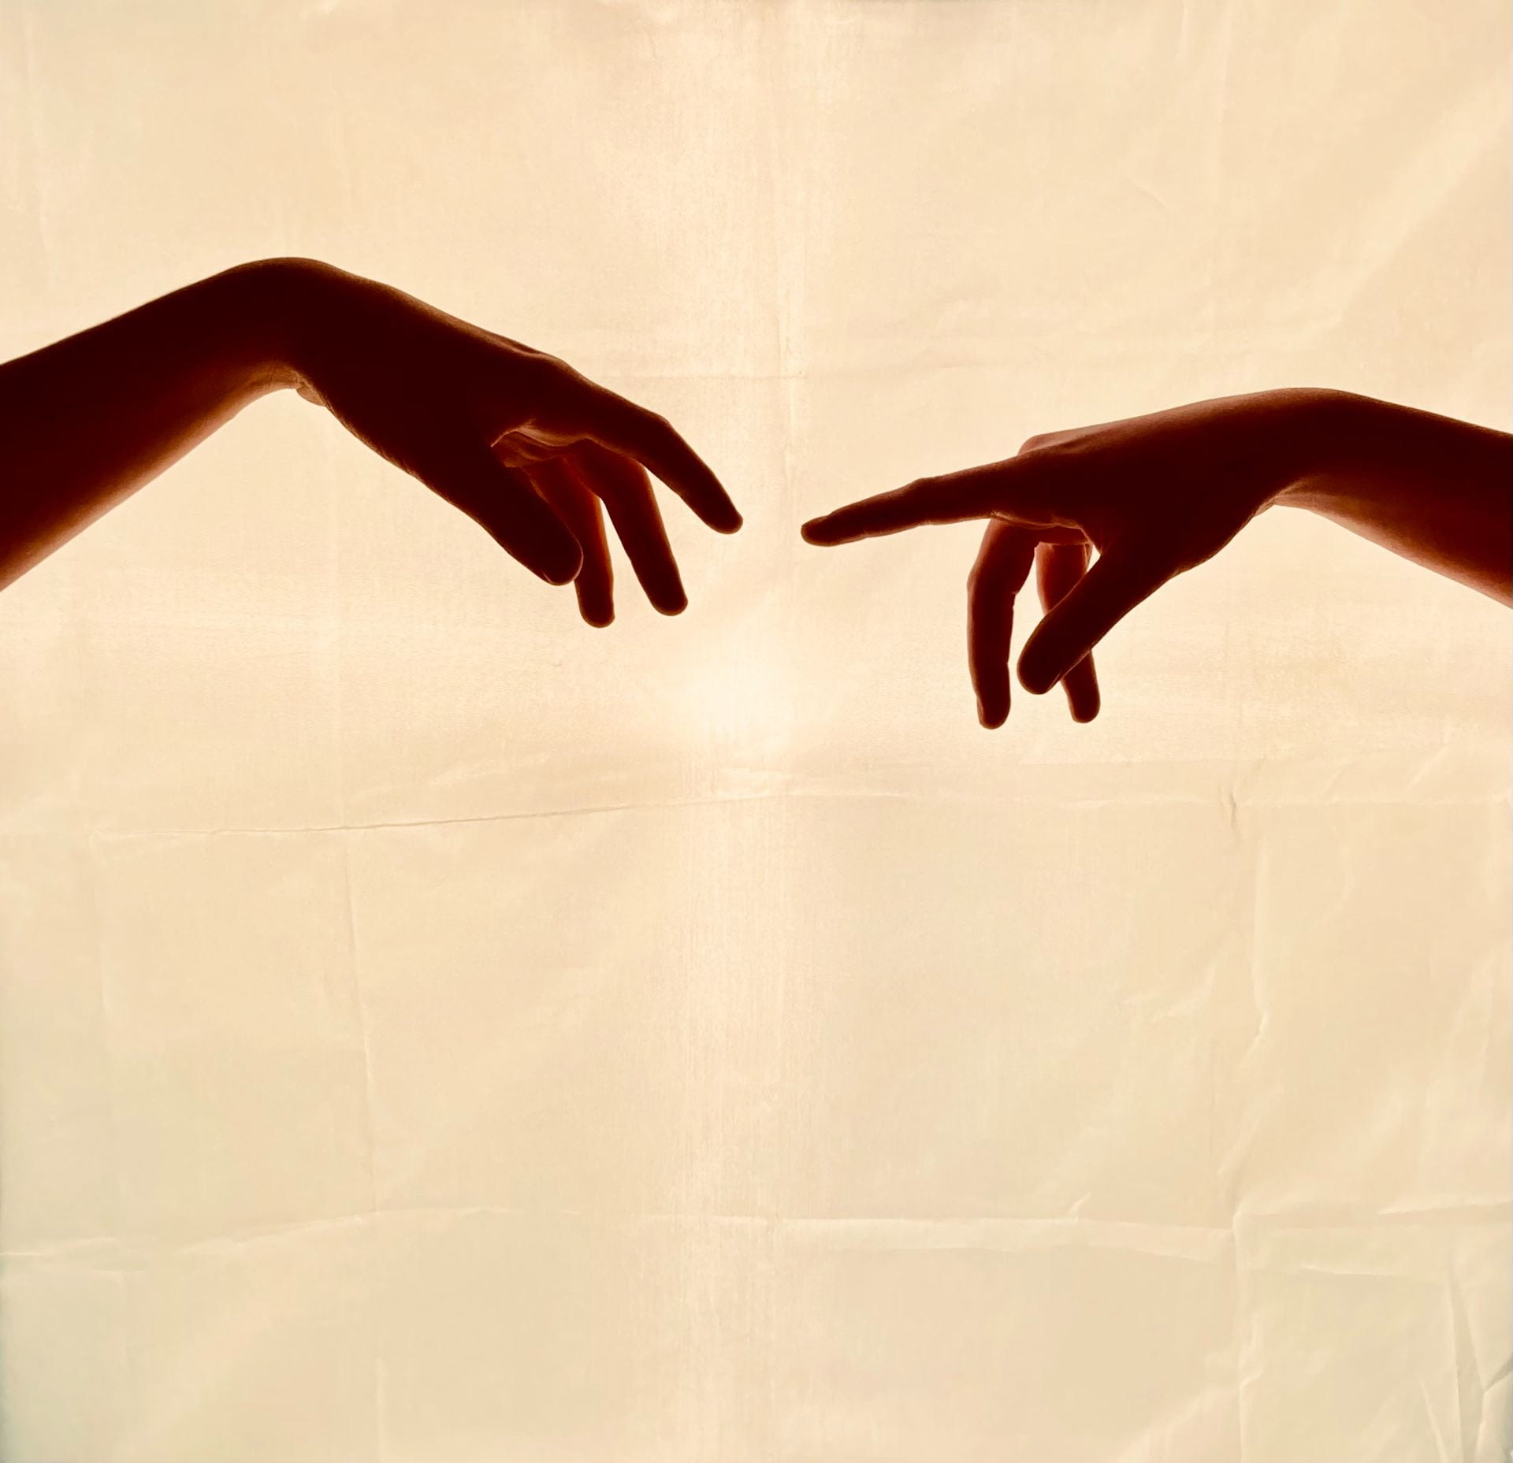Photo by Aysia Cluff
I think this photo is really cool. The background looks really cool and I love how there's a bright center where the light is and just fades a bit as it moves away. The light on the hands is really attractive to they eyes and makes it look so professional. I like the colors and how majestic and mysterious it seems.

